Texture Synthesis Exercise
Documentation
Mor Sela (morsela@post.tau.ac.il) - 032511636
Michael Gendelman (genedlma@post.tau.ac.il) – ADD ME

PART I

- Introduction

In this part our goal was to find a formidable way to extract textons from a given image, so that later on we would be able to synthesize a whole new image using those textons.

- Main Challenges
  - Texton definition
Our first and foremost challenge was to define what a Texton is for us, since the term has no conclusive definition and the interpretations range from a well defined set of similar pixels to the abstract "basic element of an image".
Looking at the various definitions, sample images and our own experiments, we have come up with the following definition for our texton - a texton is a unit of single "apparent" texture-color connectivity. Texton sets are therefore sets clustered by their texture and color "reactions". Individual texton is extracted from those sets according to its spatial connectivity.

  - Texture Feature Extraction
In order to maintain the definition that we set for a Texton, we needed a system that could utilize a set of color and texture features to capture local image appearance. Such a system was already used in a previous workshop (Implementation of the article Principal-channels for One-sided Object Cutout) and proved satisfactory for our needs (additional details will be given below).

  - Texton Extraction
After securing a good system for extracting features and segmenting them (using kMeans), we were left with sets of data which have to be broken into individual textons. That has become the main challenge of the exercise and many attempts were made to try and divide the cluster in the most accurate way. We'll recount some of the tries before moving forward:
- An attempt was made to recover the textons comparing local histograms for windows at varying sizes. That has proven almost reasonable, if the size of the texton window was given beforehand. As it seemed to be too texton-size specific, this approach was dropped.
- An attempt was made to recover the textons by computing cluster neighborhood-histogram for each pixel, segmenting the results using kMeans, acquiring a new set of clusters. Afterwards we computed the 'mean' of each such set and 'colored' all the areas that were as close as the normal divided by a constant to the mean. That gave us a rough estimate as to the local area of each texton.
- Looking for a more precise way to find the texton boundaries, some attempts were made to find good boundary detectors. After trying various detectors we have come up with Canny edge detector, which proved a worthy tool. After tuning this operator we have been able to successfully retrieve texton edges.
- Applying both (ii) and (iii) and using the knowledge we have retrieved from them, we conjectured an algorithm that based on the type of the pixel (edge, cluster, un-cluster) extracts entire textons.
- After tuning some of the parameters of the canny operator and smoothing the given image by pyramiding, we have decided that there is no real need for the method we used in (ii) and therefore dropped it. The method to find the textons has then become to smooth the current cluster, find the textons edges and then assign each pixel a texton according to its spatial location.

  - Background definition
A definite challenge with synthesizing a new image was dealing with images with various backgrounds. As background tend to be behave chaotically, it is hard to differ them from the "foreground" textons – that's why we decided background should be dealt with the same as textons, apart from background that are, in our definition, image filling – meaning that they tend to stretch from on image side to the other – and then they are treated a little differently.
Before that, we tried to differ background by computing the textons variance across a cluster, and by checking it against a threshold, decide if the cluster in not "variant enough" and is thus treated as background. This approach failed, as some textons that were not background were treated as background and as it failed to capture textured background and basically failed to create a better synthesized image than without it.

- Method Principles
  - Texture Feature Extraction
We have employed a system as described in (1) that was already implemented for a previous workshop, and thus only a few minor changes were made.
The system diagram is given below:

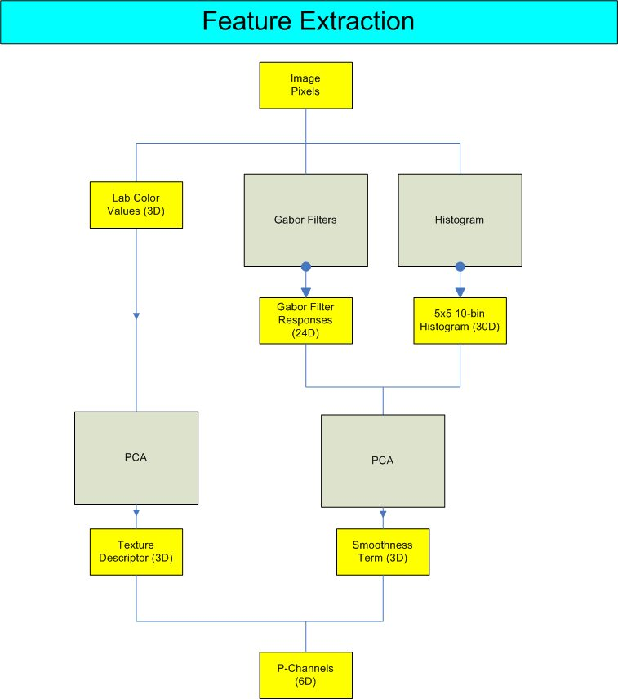

Basically the process itself uses three types of raw features: (1) the Lab color values (a 3-vector); (2) A vector of length 30 depicting the color histogram of a local patch; and (3) A set of 24 Gabor filter outputs.
More specifically, the color distribution of a local 5 x 5 neighborhood is estimated channel-by-channel by employing histograms. Each histogram contains 10 bins, and we have three such histograms corresponding to the R, G and B channels. To obtain local spatial structure descriptors, we use a battery of Gabor filters in 4 different scales and in 6 orientations. For each image pixel the vector of length 24 of filter outputs forms the frequency encoding part of the texture descriptor.
We then apply PCA to the concatenated Gabor and histogram vectors to extract the three most prominent texture based channels. The Lab 3-vectors are also transformed via PCA. Concatenating the results gives us the 6 most prominent channels.

  - Clustering
We apply kMeans on the 6 vectors extracted in the previous level (with the number of clusters k as a user input) to obtain k different clusters.
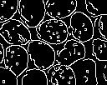
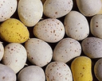
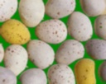
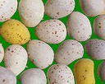
(1)
(2)
(3)
(4)
  - Texton Extraction
In order to extract textons from the given clusters, the following process occurs for each cluster:
(1) The current cluster pixels are colored while the other are blackened out.
(2) The image is blurred a little bit by using a gaussian-pyramiding scheme.
This step is supposed to reduce the amount of insignificant edges (but to maintain "hard edges" – edge preserving smoothing).
(3) The canny edge detector operator is applied on the gray level result of the previous stage and returns a black and white image indicating the proximate edges of the picture.
(4) Using the result data a texton map is constructed by going pixel by pixel and trying to grow the texton as much as possible from each pixel to its 4 neighbors until hitting a border (a basic region growing algorithm).
When no more pixels are left that can be assigned to the current texton, a check is performed to determine whether the texton size is greater than a given threshold, if so, we discard the pixels assigned to the texton, to be assigned later on, otherwise we move on to build the next texton.
At the end we have an (almost) full texton map. We then 'fix' the pixels that were not assigned to any texton by assigning them to the closest texton, if only one exists. Then we go all over the texton map, trying to fix any small 'holes' that may appear in the texton (due to being part of other cluster).
After we have a full texton map, we can just go texton by texton and extract the exact texton in any shape we like.

- Results
The algorithm thrives when given "easily" separated images (only part of the result textons are shown):

(1) 3 clusters – irregular image. We can see that due to the relative separation of the eggs the algorithm succeeds in partitioning the input image quite successfully.

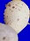
I
II
III
(2) 2 clusters – As the difference between the two classes is great, the textonization here works.

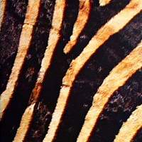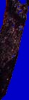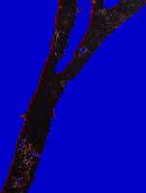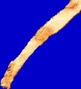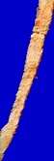
I
II

(3) 2 clusters – irregular pattern. Although it may seem like a problematic picture, the stones are easily separated and the background and the foreground are easily discerned.

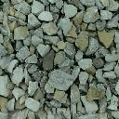
I
II

(4) 2 clusters – near regular image
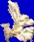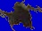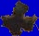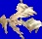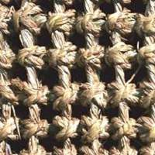
I
II
(5) 2 clusters

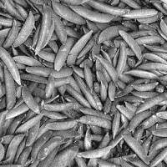
I
II
(6) 2 clusters – near stochastic example. The textons here are quite similar and does not have a definite shape.

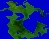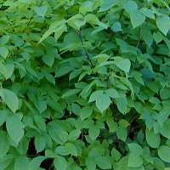
I
II

(7) 2 clusters. The algorithm takes series of small paintpeels to be a texton, as these series makes are dully connected.

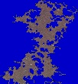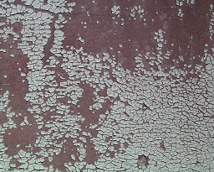
I
II

(8) 2 clusters

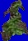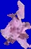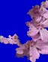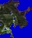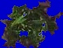
I
II

The algorithm performs less well when the textons in question are connected poorly or just unconnected.

(1)
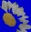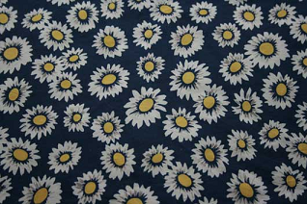
I
II
As one can see, the algorithm does capture the 'intent' of the image, but as it does it, it loses parts that may be relevant.

Another known issue is dealing with background. If the background is the dominating part of picture, the algorithm may refer to it all as texton (not necessarily bad, but still worth noting):

(1)
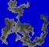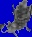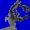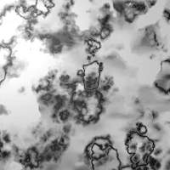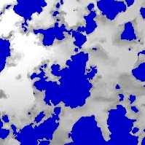
I
II
(2)
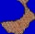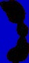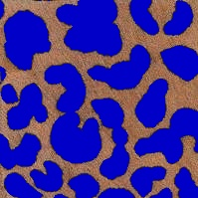
I
II

In some images, the definition of texton as we see it does not exist, which means the algorithm performs less well (as the connected shapes does not match to a known substant).:

(1)
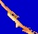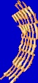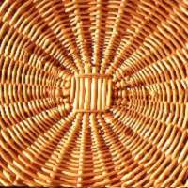
I
II

(2)
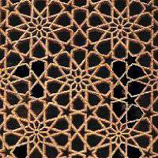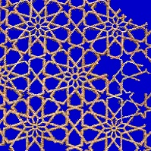
I
II

There are cases where the algorithm fails to recognize any textons, mostly because of 'wrong segmentation' – a texton that is split among several clusters:

(1) 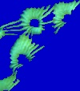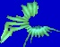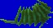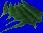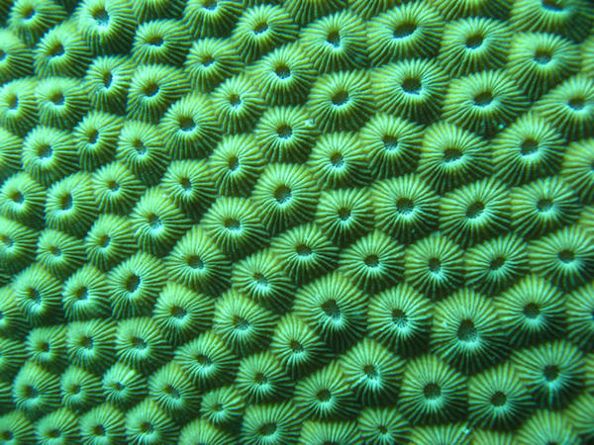
I
II

- Discussion
As the results prove, the algorithm behaves well when encountered with 'easy to discriminate' examples (good examples)– much of the examples where textons are defined clearly were properly extracted. Examples for such images are rocks, stripes, eggs and so on.
As mentioned through the results part, there are several cases in which the algorithm does not deliver (Bad examples) – textons that are made of several different textures – for those the clustering achieved by kMeans makes the texton partial; Textons which has no visible boundaries – If they can't be broken using canny boundary detection the result is a massive texton, or a "more than a texton" result; Or textons that are not defined well – such textons cannot really be easily separated as their boundaries are irrelevant to the texton nature.

- Improvements
The current algorithm deals poorly with too varying a texture – if a texton is made of several parts, which are assigned to different cluster, the result will be incomplete.
Another problem that should be dealt with in the future is the ability to discern between background and foreground. If such an ability would have existed, we could have found more connected textons, and would have been able to be more lax with adding partial textons parts from other clusters to make a full texton.

PART II
- Introduction
In this part our goal was to synthesize a new texture as best as we can from the input image using the textons acquired by the previous part.

- Main Challenges
  - Spatial organization conservation
In the previous part we have successfully acquired precise textons (meaning we have the texton image itself and not a bounding box and its alikes), which means the act of putting them together was not constrained by artifacts that may occur, unless the texton itself was "artifacted". Due to that fact, the main challenge became finding a good way to put all the textons in a fashion that is similar to the input image. At first we tried to "throw" the textons randomly, but the results were less then satisfactory. Therefore we decided to use co-occurrence relations as described in ⁽¹⁾.
Note that unlike ⁽¹⁾ we do consider correlation among the positions of particles of different classes.

  - Background definition
As was declared in part I, a major challenge was to decide what a background texton is. At first we tried to define the background texton as texton that is "image-filling" – meaning that he's almost as big as the input image. As can be expected, the definition worked in several places, and in some others it failed miserably.
FILL ME

  - Background creation
Even after finding the background texton, we still needed to find a good algorithm to synthesize it, apart from the other clusters. As that texton may have contained holes, we could not just put it as a background. The first try was to take random pixels from the texton and put them at random places and by that to fill the background. The result was too varying, so we tried to dilate it a little, to acquire smoother texture. The result did look better, but was only a shadow representation of the original background.
Seeing that, we've decided to use an algorithm similar to lapped textures ⁽⁶⁾ and by that we acquired a nice looking background.

- Method Principles
  - Co-occurrences Computation
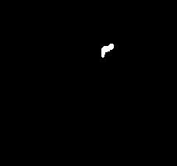
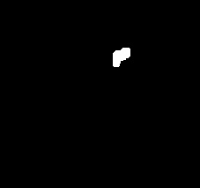
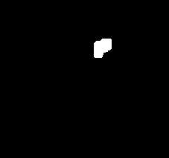
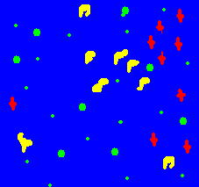
In this step we analyze the positions of the neighboring particles for each texton.
Overlap!
Returning to the texton extraction part, we added a co-occurrences computation after the textons was extracted. For each of the textons in each cluster we applied a morphological dilation operation, growing the texton by a one-pixel-thick contour each step until reaching the first overlap with a neighboring texton. Noting this dilation size we continued on until a pre-defined threshold was reached. Through all this process we noted all the textons we "collisioned" with.
Using that information we compute a list of co-occurrences related to each texton, where one co-occurrence is defined a triplet (dx, dy, c). c is the cluster number of the neighboring texton. (dx, dy) represent the distances between the bounding boxes of the concerned textons. In order to improve the synthesis process we tried to maintain at least 4 neighbors for each of the texton quadrants. In cases for which there is missing texton in one quadrant, we simply use the symmetric co-occurrence (the one of the opposite quadrant, if exists).
We use the distance between couples of textons bounding boxes – and not the distance between their centers, to be able, during the synthesis, to take into account the possibly varying sizes of the textons.
For each texton we compute a list of co-occurrences. This set characterizes the spatial distribution of the particles.
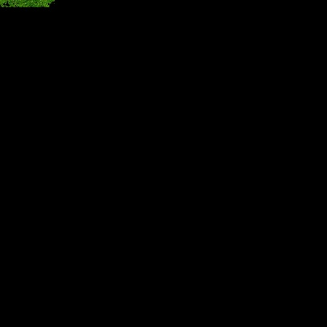
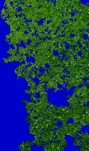
There is one exception for this method. Background cluster are handled differently, as they cover an entire surface and cannot be relied on a neighbor texton. Thus, those textons ignored in the co-occurrence computation process and are used only in the background creation process.

  - background Creation
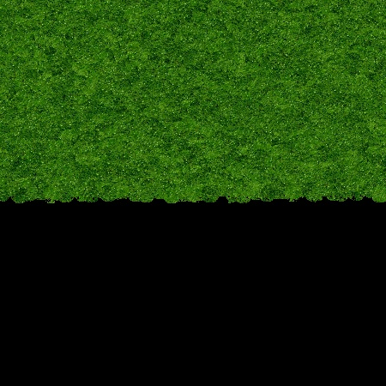
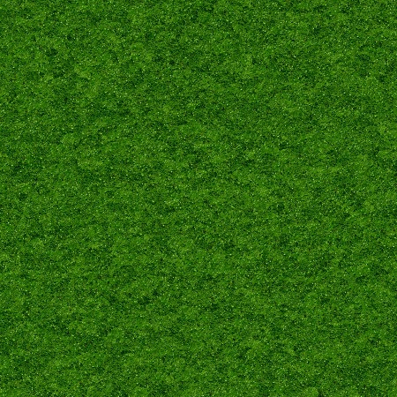
In this step we process the background of the synthesized image using the background texton (if exists) in order t ensure the whole surface is covered without holes. The technique we use to do that is similar to lapped textures.
A splotch, in our case, a circle, is taken randomly from the background texton and is pasted onto a chosen spot in the background texton. That process continues until the whole background is filled with the random splotches.

  - Texture Synthesis
In this step we use all the previous knowledge we acquired in order to synthesize a whole new image.
First, all the incomplete textons are removed (all the textons that are cut by the border). Then, all the "too-close" textons are removed (touching textons in a no-touching-textons picture) in order to remove problematic textons.
The first texton is chosen randomly from the first class and is inserted in the middle of the synthesized image. The texton co-occurrence list is inserted into the co-occurrence queue. New randomly chosen particles are put on the respective location given by the co-occurrences, if there is not already a particle close to this location. The proximity of particles is checked by using the bounding boxes and the pre computed dilation (as mentioned in 3.1), if there is too much over lapping, then no new texton is created.
The texture is constructed progressively, by adding more and more textons from all of the clusters, according to the spatial arrangements.
The process is stopped when no new textons can be added.

After the foreground texture is created, it is combined with the background texture computed earlier.

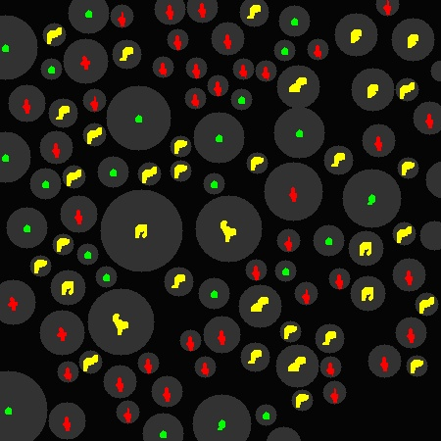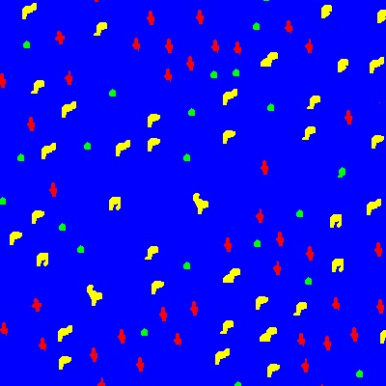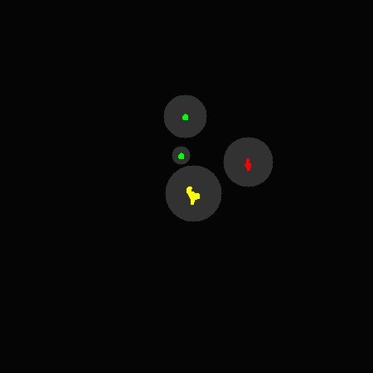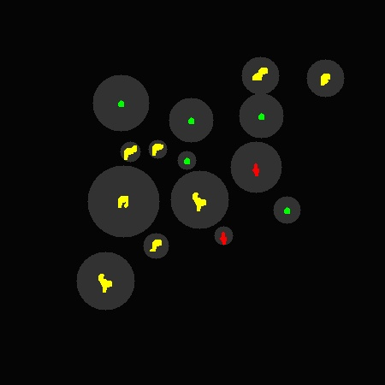
- Results

HERE BE RESULTS

- Discussion
- Implementation Specifics
The application was written in C++ under Windows and was based mainly on OpenCV 1.0.

  - Used Libraries
    - OpenCV
OpenCV is the main library used in our project. OpenCV is Intel's computer vision library. Most of the data structures we used are from this library (CvMat, IpImg). Main functions used were Matrices, Images and arrays manipulations.
The Gabor filters module we use in the feature extraction part was created by Mian Zhou and is also based on OpenCV library.
In order to use OpenCV, one should obtain the OpenCV_1.0.exe installer and add the proper paths to the compiler.
In order to run a program that uses OpenCV libraries, one should have all the required OpenCV dlls.

    - Feature Extraction
As mentioned before, almost the whole feature extraction system was taken from a previous workshop that was done by Mor Sela. The system includes Gabor filters support, 3 Lab color extraction and histogram support. All of these features are combined together with PCA.

  - Usage

Texturesynth.exe –i image_file_path –o [output_path] -w [new_width] -h [new_height] -cn [cluster_number] -mts [minimum_texton_size]

image_file_path (mandatory) - The path of the image on which we want to apply the texton extractor.
output_path – The path where output images will be saved.
new_width – The synthesized image width. If not given, the width will be as the input image width.
new_height – The synthesized image height. If not given, the height will be as the input image height.
cluster_number – [default = 2]. The number of clusters in the picture, if the picture is made of more than two "different textons", the user may have the option to increase the number of different clusters.
minimum_texton_size – [default = 30]. The size of the minimal texton is pixels.

- References
1. Principal-channels for One-sided Object Cutout. Lior Gavish, Lior Wolf, Lior Shapira and Daniel Cohen-Or

2. Texture Particles. Jean-Michel Dischler, Karl Maritaud, Bruno Lévy, Djamchid Ghazanfarpour. Computer Graphics Forum (Eurographics) 2002

3. Visual learning by integrating descriptive and generative methods (2001) Cheng-en Guo, Song-chun Zhu, Yingnian Wu
Proc. of Int’l Conf. on Computer Vision

4. Textons, Contours and Regions: Cue Integration in Image Segmentation. Jitendra Malik, Serge Belongie, Jianbo Shi and Thomas Leung. IEE International Conference on Computer Vision 1999

5.. Lapped textures. E. Praun, A. Finkelstein, H. Hoppe. ACM SIGGRAPH 2000 Conference Proceedings, 465-470.

6.. Hybrid Texture Synthesis (2003). Nealen and Alexa . Eurographics Symposium on Rendering 2003 (14th Eurographics Workshop on Rendering), pages 97-105

7. 5. Gabor filter implementation. Mian Zhou
http://www.personal.rdg.ac.uk/~sir02mz/

